

Faculty of Information Technology

***Computer Science Department***

***Artificial Intellignce***

Project Title

Graduation Project (1/2) Report

Prepared by:

|  |  |
| --- | --- |
| **Students Name** | **Student ID** |
| **Alaa AL-Joubeh** | **202020107** |
| **Khaled AL-Qadi** | **202010591** |
|  |  |
|  |  |

Supervised by:

DR-Mohammad AL-Hawarat

**To obtain**

**BSc in Computer Science/Artificial Intelligence**

Semester / Academic Year

Group No.: AI-23-1-1-**serial** (replace **serial** by group serial number)

Copyright © 2023-2024 - All rights reserved

Middle East University

|  |
| --- |
| Declaration **إقرار الملكية** |
| Declaration  We hereby acknowledge that the work presented in this document report and the ideas based upon are the group members own unless stated otherwise and properly cited in text and referenced at the end of the document.   |  |  |  |  | | --- | --- | --- | --- | | Date | Signature | Students Name | Student ID | |  |  |  |  | |  |  |  |  | |  |  |  |  | |  |  |  |  | |
|  |

|  |
| --- |
| Supervisor Approval **موافقة المشرف** |
| **APPROVAL FOR SUBMISSION**  I certify that this project report entitled “**TITLE TO BE THE SAME AS THE FRONT COVER, CAPITAL LETTERS, BOLD**” was prepared by **STUDENT’S NAME** has met the required standard for submission in partial fulfillment of the requirements for the degree of Bachelor of Science in …………………………………. at MEU.  Approved by  Signature: ……...……..………………………..................  Supervisor: Dr…..…….…………………………………  Date: ……………..……………………………………… |
|  |

Table of Contents

Declaration 2

Supervisor Approval 3

Acknowledgement 5

Abstract (English) 6

Abstract (Arabic) 7

List of Figures 9

List of Abbreviations 10

List of Abbreviations 11

**Chapter 1: Introduction** 12

**Chapter 2: Background** 13

**Chapter 3 – Literature Review** 14

**Chapter 4 – Dataset** 15

**Chapter 5 – Methodology** 16

**Chapter 6 – Results (if any)** 17

**Chapter 7 – Discussion (if results provided)** 18

**Chapter 8 – Conclusion** 19

**REFERENCES** 20

**APPENDICES** 21

|  |
| --- |
| Acknowledgement **صفحة الشكر والعرفان** |
| **ACKNOWLEDGEMENT**  I would like to thank everyone who had contributed to the successful completion of this project starting from the guidance of our supervisor Dr. ……………… and the team work with my colleagues who worked with this project Dr. ………., Mrs/Miss………. |
|  |

|  |
| --- |
| Abstract (English) **المستخلص (إنجليزي)** |
| **Title**  contains short, descriptive title of the proposed thesis project (should be fairly self-explanatory)  and author, institution, department, research mentor, mentor's institution, and date of delivery  **ABSTRACT**  the abstract is a brief summary of your thesis proposal  its length should not exceed ~250 words  present a brief introduction to the issue  make the key statement of your thesis  give a summary of how you want to address the issue  include a possible implication of your work, if successfully completed |
|  |

|  |
| --- |
| Abstract (Arabic) **المستخلص (عربى)** |
| **عنوان المشروع**  **المستخلص** |
|  |

|  |
| --- |
| List of Figuresقائمة الأشكال |
| **LIST OF FIGURES**  **FIGURE TITLE PAGE**  2.1………………………………………………………………………….….12 |
|  |

|  |
| --- |
| List of Abbreviations **قائمة الاختصارات** |
| **LIST OF SYMBOLS/ABBREVIATIONS**  NLP Natural Language Processing  SA Sentiment Analysis  CNN Convolutional Neural Networks |
|  |

|  |
| --- |
| List of Abbreviations **قائمة الاختصارات** |
| **LIST OF KEYWORDS** |
|  |

# **Chapter 1: Introduction**

1.1 Problem Statement and Purpose

1.2 Project and Design Objectives

1.3 Intended Outcomes and Deliverables

At the conclusion of this project, the following outcomes are expected:

A complete process framework ...

1.4 Motivations

In this section, state the reasons and motivation for choosing the project, problems it is trying to solve, and the impact of your solution to society, human kind, etc.

1..5 Outline of Report

# **Chapter 2: Background**

After consulting with our supervisor we decided to generate a chatbot that can answer those questions in addition to other questions such as general university information( when it was established, how many buildings there are, what are the available majors… etc).

Answering those questions will be on the chatbot website, which allows access only for MEU students, by entering their emails (university numbers) and their passwords. However, a chatbot would not be allowed to answer questions that are not related to the college.

# **Chapter 3 – Literature Review**

1-Arizona State University

Arizona State University’s chatbot website is a strategic initiative aimed at improving student support and engagement through technology. By providing a user-friendly, accessible, and efficient platform for information and assistance, the chatbot helps streamline university operations and enhance the student experience ASU’s chatbot website offers numerous benefits in terms of efficiency, accessibility, and cost-effectiveness, but it also has limitations that need to be addressed to ensure comprehensive and satisfactory student support.

Advantages:  
1. 24/7 Accessibility: Students can access support at any time, making it convenient and responsive to their needs.  
2. Efficiency: The chatbot automates routine inquiries, reducing wait times and allowing staff to focus on more complex issues.  
3. Personalization: Personalized responses based on user profiles enhance the relevance and effectiveness of the assistance provided.  
4. Cost-Effective: Reduces the need for extensive human resources to manage high volumes of queries, saving costs for the university.  
5. User-Friendly: An intuitive interface makes it easy for students to find the information they need quickly.  
6. Immediate Information: Instant answers to frequently asked questions help students resolve issues promptly.

Disadvantages:  
1. Limited Scope: The chatbot may not be able to handle all types of queries, especially complex or nuanced issues that require human intervention.  
2. Dependence on Technology: Technical issues or outages can disrupt the service, potentially leaving students without support.  
3. Impersonal Interaction: Some users might find the interaction with a chatbot less satisfying compared to speaking with a human representative.  
4. Learning Curve: Students and staff may need time to get accustomed to using the chatbot effectively.  
5. Data Privacy: Handling sensitive information through the chatbot requires robust security measures to protect user data.

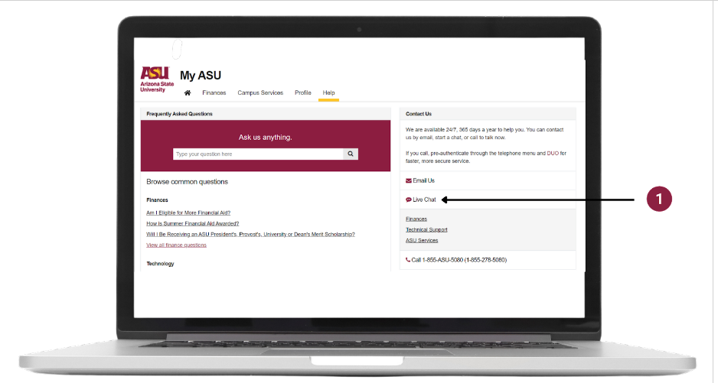

2-Georgia Tech

Georgia Tech's chatbot is designed to enhance student engagement and streamline access to university resources. It offers support across different aspects of student life, including academic, administrative, and social services.

Features and Functions:  
1. 24/7 Availability:  
   - The chatbot is accessible anytime, offering support around the clock.

2. Instant Responses:  
   - Provides immediate answers to frequently asked questions about admissions, enrollment, financial aid, course schedules, and campus events.

3. Personalized Assistance:  
   - Uses student data to tailor responses, making the interaction more relevant to individual needs.

4. Seamless Integration:  
   - Can escalate issues to human advisors if they cannot resolve them, ensuring that students receive comprehensive support.

5. Academic Support:  
   Offers information on academic resources, tutoring, and advising services.

6. Campus Information:  
   - Provides details on-campus services like housing, dining, transportation, and health services.

7. Event Notifications:  
   - Keeps students informed about upcoming events, workshops, and activities on campus.

Advantages:  
1.24/7 Accessibility:  
   - Students can get help anytime, increasing convenience and accessibility.  
  
2. Efficiency:  
   - Reduces wait times by automating responses to common queries, allowing university staff to focus on more complex tasks.  
  
3. Personalization:  
   - Delivers customized responses based on student profiles, improving the relevance of the information provided.  
  
4. Cost-Effective:  
   - Minimizes the need for extensive human resources to manage routine inquiries, leading to cost savings.  
  
5. User-Friendly:  
   - An intuitive interface makes it easy for students to navigate and find the information they need quickly.  
  
6. Immediate Information:  
   - Provides quick answers to frequently asked questions, helping students resolve issues promptly.

Disadvantages:  
1. Limited Scope:  
   - May struggle with complex or unique queries that require human judgment or intervention.  
  
2. Technical Issues:  
   - Reliance on technology means that outages or bugs can disrupt service, potentially leaving students without support.  
  
3. Impersonal Interaction:  
   - Some students may prefer human interaction and find the chatbot experience less satisfactory.  
  
4. Learning Curve:  
   - Both students and staff may need time to adapt to using the chatbot effectively.  
  
5. Data Privacy: Ensuring the security of sensitive student information handled by the chatbot requires robust measures to protect against data breaches.

# 

# **3-** Carnegie Mellon University (CMU)

Carnegie Mellon University (CMU) has developed an advanced chatbot to enhance student services and streamline access to information. Here’s an in-depth look at its features, advantages, and potential drawbacks:

1. 24/7 Availability:  
   - The chatbot is designed to be available at all times, providing support whenever students need it, without being restricted by office hours.

2. Immediate Responses:  
   - Students can receive quick answers to a wide array of questions including:  
     - Admissions: Information on application processes, deadlines, and requirements.  
     - Enrollment: Guidance on course registration, drop/add periods, and academic calendars.  
     - Financial Aid: Details on scholarships, grants, loans, and application procedures.  
     - Academic Schedules: Information on class schedules, exam dates, and academic advising.

3. Personalized Interactions:  
   - The chatbot uses data from student profiles to offer customized responses. For instance:  
     - Tailored Academic Advice: Based on the student’s major and course load.  
     - Event Recommendations: Suggesting events and activities relevant to the student’s interests and academic pursuits.

4. Integration with Human Support:  
   - For more complex or sensitive inquiries, the chatbot can escalate the conversation to a human advisor. This ensures:  
     - Seamless Transition: Maintaining the context of the conversation.  
     - Comprehensive Support: Providing human intervention where necessary.

5. Academic and Campus Resources:  
   - The chatbot provides comprehensive information about:  
     - Tutoring and Advising: Connecting students with academic support services.  
     - Library Services: Information on borrowing books, accessing online resources, and research assistance.  
     - Campus Facilities: Details on housing, dining options, transportation, and health services.

6. Event Notifications:  
   - Students are kept informed about:  
     - University Events: Lectures, seminars, cultural events, and sports.  
     - Workshops: Career services, skill-building sessions, and academic workshops.  
     - Extracurricular Activities: Clubs, student organizations, and social gatherings.

Advantages:

1. Round-the-Clock Access:  
   - The chatbot’s 24/7 availability ensures that students can get help anytime, which is particularly beneficial for international students and those with irregular schedules.

2. Efficiency in Handling Queries:  
   - By automating routine inquiries, the chatbot significantly reduces wait times and allows university staff to focus on more complex and personalized support tasks.

3. Personalized Assistance:  
   - The use of data-driven insights allows the chatbot to offer more relevant and customized support, enhancing the student experience.

4. Cost Savings:  
   - Automating frequent inquiries reduces the need for extensive human resources, leading to operational cost savings for the university.

5. User-Friendly Interface:  
   - The chatbot is designed to be intuitive, making it easy for students to navigate and find the information they need quickly and effortlessly.

6. Prompt Information Delivery:  
   - Ensures students receive timely answers to their questions, facilitating quick resolution of issues and aiding in effective time management.

Potential Drawbacks:

1. Handling Complex Queries:  
   - The chatbot might not be equipped to handle highly complex or unique questions that require nuanced understanding or human judgment.

2. Technical Reliability:  
   - Dependence on technology means that any technical issues, such as server outages or software bugs, could disrupt service availability.

3. Perceived Impersonality:  
   - Some students may prefer human interaction and might find the chatbot experience less personal and engaging.

4. Adaptation Period:  
   - Both students and staff might require time to become accustomed to using the chatbot effectively. Training and familiarization sessions could mitigate this issue.

5. Data Security Concerns:  
   - Ensuring the protection of sensitive student information is crucial. The university must implement robust security measures to safeguard data against breaches

# 

# **4-** Duke University

Duke University has developed a chatbot for students, designed to enhance their engagement and support by providing an accessible and interactive platform for information and assistance. Here's a concise overview, along with the advantages and disadvantages:  
Duke University's chatbot is an AI-powered tool aimed at improving the student experience by offering real-time support and information across various aspects of university life.

Features and Functions:  
1. 24/7 Availability:  
   - The chatbot is available at all times, ensuring students can get help whenever they need it.

2. Instant Responses:  
   - Provides quick answers to common questions related to admissions, registration, financial aid, campus events, and more.

3. Personalized Assistance:  
   - Uses data from student profiles to offer tailored responses, making interactions more relevant and efficient.

4. Escalation to Human Advisors:  
   - If the chatbot cannot resolve an issue, it can escalate the query to a human advisor for further assistance.

5. Academic Support:  
   - Offers information on academic resources, course schedules, tutoring services, and advising.

6. Campus Services:  
   - Provides details about campus services, including housing, dining, transportation, and health services.

7. Event Updates:  
   - Keeps students informed about upcoming events, workshops, and activities on campus.

Advantages:  
1. 24/7 Accessibility:  
   - Students can access support at any time, making it highly convenient.  
  
2. Efficiency:  
   - Automates routine inquiries, reducing wait times and freeing up university staff for more complex issues.  
  
3. Personalization:  
   - Delivers customized responses based on individual student profiles, enhancing the relevance of the information provided.  
  
4. Cost-Effective:  
   - Reduces the need for extensive human resources to manage frequent inquiries, leading to cost savings.  
  
5. User-Friendly Interface:  
   - An intuitive design makes it easy for students to navigate and find the information they need quickly.  
  
6. Immediate Information:  
   - Provides instant answers to frequently asked questions, helping students resolve issues promptly.

Disadvantages:  
1. Limited Scope:  
   - May struggle with complex or unique queries that require human judgment or intervention.  
  
2. Technical Issues:  
   - Reliance on technology means that outages or bugs can disrupt service, potentially leaving students without support.  
  
3. Impersonal Interaction:  
   - Some students might find the chatbot experience less satisfying compared to speaking with a human representative.  
  
4. Learning Curve:  
   - Both students and staff may need time to adapt to using the chatbot effectively.  
  
5. Data Privacy:  
   - Ensuring the security of sensitive student information handled by the chatbot requires robust measures to protect against data breaches.

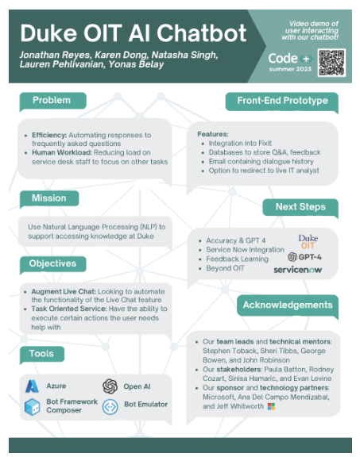

5-BOTaina

, the chatbot created by Virginia Commonwealth University School of the Arts in Qatar, is a product of artificial intelligence (AI). To enhance user interaction, BOTaina was endowed with a humanized appearance and personality of a twenty-something Qatari girl. Aisha Al-Fadhala, a QF partner university, designed BOTaina's avatar, by introducing BOTaina to the digital world, we are demonstrating our ongoing commitment to improving communication channels to better serve people's needs.

She offers users of our website a personalized, humanized experience that resembles a conversation, answering their queries right away and motivating them. Her ultimate goal is to become a virtual assistant that can be found on many QF communication platforms.

# **Chapter 4 – Dataset**

Data selection, description, collection, pre-processing and usage.

# **Chapter 5 – Methodology**

Methods Used

1. Requirement Analysis:

We asked IT students about the problems they face regarding current semester courses, course requirements, course availability, and professors' office hours. So we decided to generate a chatbot that can answer those questions in addition to other questions such as, general university information( when it was established, how many buildings there are, what are the available majors… etc).

Answering those questions will be on the chatbot website, which allows access only for MEU students, by entering their emails (university numbers) and their passwords. However, the chatbot would not be allowed to answer questions that are not related to the college.

2. Design and Development:  
design a bar for question space for asking the chatbot   
design a bar for the chatbot answer space    
design the website page prototype on paper  
we will implement the design steps   
we will develop a website that requires a student ID number to access the chatbot so no intruders can access the university information  
when the student asks in the question bar it will send an information request from the dataset server, and then the Python model processes the dataset   
then the answer will be sent to the answer bar on the website

4. Testing

After generating and designing the website, we will test its functionality by asking the students to try using it and recording their feedback, so we can be aware of how it can handle the process and fix any issues or problems if happen to ensure sufficient work.

.

5. Deployment:

- Integrate the chatbot into the university’s existing digital infrastructure (e.g., website, mobile app).

- Ensure the chatbot is accessible and easy to use for all students.

Data Collection and Analysis

1) we provide a formal request from the university administration for a copy of information technology faculty about each department's guidance plan

 2) using the department’s guidance plan we process them so we can take advantage of them

3) we train the chatbot about this dataset

 data analyzing:

 Using python models, we implement the final project result

 Using machine learning models to enhance model accuracy

- Use machine learning algorithms to continuously enhance the chatbot’s performance based on user interactions.

Materials Used

- Software:

- Development Environment: Python, Node.js

- NLP Libraries: NLTK, spaCy

- Chatbot Platforms: Dialogflow, Microsoft Bot Framework, Rasa

- Documentation:

- User Manuals: Detailed guides for users on how to interact with the chatbot.

- Technical Documentation: Comprehensive documentation of the code, design, and architecture of the chatbot.

Calculations, Techniques, and Procedures

- Calculations:

- Performance Metrics: Calculate precision, recall, and F1 score to evaluate the chatbot’s accuracy.

- Response Time: Measure the average response time of the chatbot to ensure it meets user expectations.

- Techniques:

- Machine Learning: Use supervised learning techniques to train the chatbot on labeled datasets.

- Natural Language Processing: Implement tokenization, entity recognition, and intent classification to understand user queries.

- Procedure:

1. Gather and preprocess data.

2. Train and validate the chatbot model.

3. Deploy the model to the chosen platform.

4. Monitor and iterate based on user feedback.

- Equipment and Calibration Graphs:

- Utilize server logs and analytics tools to monitor the chatbot’s performance.

- Create calibration graphs to visualize the chatbot’s response accuracy over time.

Limitations, Assumptions, and Range of Validity

- Limitations:

- The chatbot may not handle highly complex queries that require in-depth knowledge or context.

- Language and phrasing variations can affect the chatbot’s ability to understand and respond accurately.

- Assumptions:

- Users will primarily ask questions related to academic programs, schedules, and campus events.

- The chatbot will be used within the scope of the university environment.

- Range of Validity:

- The chatbot is designed to handle queries within the university context and may not apply to other institutions.

- Its effectiveness depends on the quality and extent of the training data.

Citations

Citations will be limited to data sources used for training the chatbot and more comprehensive descriptions of the procedures, such as official documentation of the NLP libraries and chatbot platforms.

This methodology ensures a systematic approach to developing an effective and user-friendly chatbot for our university. The detailed steps and considerations outlined above will guide us through the project, from initial requirements gathering to deployment and ongoing improvement.

# **Chapter 6 – Results (if any)**

Provide the results objectively without interpretation

# **Chapter 7 – Discussion (if results provided)**

Interpret the results and their impact

Implications of Research

Link the results with the related studies listed in Chapter Three (Literature Review)

What new knowledge will the proposed project produce that we do not already know?

Why is it worth knowing, what are the major implications?

# **Chapter 8 – Conclusion**

8.1 Summary: summary of the work done including results, contributions, and major findings.

8.2 Limitations: What are limitations and obstacles faced during the project.

8.3 Future work: Suggest either what is the plan for project 2, or how other students can carry on based on your work.

# **REFERENCES**

Cite all ideas, concepts, text, data that are not your own **in the document**

If you make a statement, back it up with your own data or a reference

All references cited in the text must be listed **here**

Do not use footnotes

Citation format: Harvard [Numbers]

# **APPENDICES**